

Princess Sumaya University for Technology

King Abdullah II school for Electrical Engineering

Computer Engineering Department

Microprocessors and Embedded systems

22442

**Smart Irrigation System**

Tariq Sulaiman 20200866 (NIS)

Email: tar20200866@std.psut.edu.jo

Isam karaman 20200365 (NIS)

Email: Isa20200365@std.psut.edu.jo

Supervised by:

Dr. Anastasia Al Gharib

Microprocessors & Embedded Systems Final Design Project-First Semester-2023/2024

**Abstract**

This project introduces a simple yet effective Smart Irrigation System controlled by a PIC16F877A microcontroller. The system incorporates a humidity sensor for soil moisture, a light sensor for day-night detection, and a temperature sensor. These sensors work together to automate plant irrigation and optimize growing conditions.

The humidity sensor ensures water is applied only when the soil is dry enough, conserving water. The light sensor distinguishes between day and night, triggering a light system for plants during low-light conditions. Additionally, a temperature sensor maintains optimal growing conditions.

A brushless water pump, driven by the microcontroller, delivers precise irrigation based on sensor inputs. The PIC16F877A microcontroller coordinates these components, making the system adaptable and resource-efficient.

This Smart Irrigation System provides a straightforward solution for conserving water and enhancing plant growth, contributing to sustainable agriculture practices.

**Contents**

**Introduction** 3

a) Background 3

b) Objectives 3

**Design** 4

a) Requirements and components 4

b) Code Description 4

c) General Block Diagram 5

d) Flow chart 6

**Problems and recommendations** 6

**4. Conclusion** 7

**5. References** 7

# **Introduction**

## a) Background

In traditional farming, water is often wasted through inefficient irrigation, and plants may not get the right amount of light and temperature needed for optimal growth. To tackle these issues, there is a rising interest in smart irrigation systems that use technology to improve how we water plants.

Smart irrigation involves using sensors to understand when and how much water, light, and heat plants need. Soil moisture sensors help determine when the soil is dry, signaling the need for watering. Light sensors help recognize if it's day or night, triggering additional light for plants when needed. Temperature sensors ensure that the environment is suitable for plant growth.

The PIC16F877A microcontroller is a small but powerful computer that can be programmed to manage these sensors and control irrigation systems. This project aims to create a simple and effective Smart Irrigation System using this microcontroller. The goal is to save water, enhance plant growth, and contribute to more sustainable and efficient farming practices.

## b) Objectives

1. **Water Conservation:** Develop a smart irrigation system to precisely measure soil moisture levels using a humidity sensor, ensuring water is only applied when necessary. This aims to reduce water wastage in agriculture.
2. **Optimized Plant Growth:** Implement a light sensor to distinguish between day and night, triggering an automated lighting system to provide plants with the necessary light conditions during low natural light periods. This contributes to enhancing overall plant growth and productivity.
3. **Temperature Regulation:** Utilize a temperature sensor to monitor ambient conditions and maintain an optimal temperature range for plant growth. This objective ensures that plants are not exposed to extreme temperature stress.
4. **Automated Irrigation Control:** Integrate the PIC16F877A microcontroller to coordinate and control the irrigation process based on the inputs from the humidity, light, and temperature sensors. This automation simplifies the management of the irrigation system.
5. **Resource Efficiency:** Design the system with a brushless water pump to ensure precise and efficient water delivery. The combination of sensors and automated control aims to minimize resource usage and maximize the impact on plant health.
6. **User-Friendly Operation:** Create an intuitive interface for users to interact with the system, allowing for easy monitoring of sensor readings and adjustment of system parameters. This objective enhances the accessibility and usability of the smart irrigation system.
7. **Energy Efficiency:** Optimize the power consumption of the system components, promoting an energy-efficient design that aligns with sustainable practices.

By achieving these objectives, the project aims to contribute to the development of sustainable and technology-driven solutions for precision agriculture, promoting water conservation, efficient resource utilization, and healthier plant growth.

# **Design**

## a) Requirements and components

Our project is required to do the following tasks:

* Track the irrigation environment.
* Irrigate the plants as it needed.

The following components were employed in the construction of the smart Irrigation system:

* **PIC16F877A microcontroller:** A programmable microcontroller that controls the pump based on the input from the temp sensors and the humidity.
* **LDR (Light Dependent Resistors):** Light-sensitive resistors used to detect the intensity of light falling on them.
* **Temperature sensor (LM35):** A sensor that reads a temp as analog.
* **Humidity sensor:** A sensor that reads the humidity from the soil and its digital.
* **Three 200Ω resistors:** Used to protect the Leds.
* **Breadboard:** A prototyping board used to connect and test the electronic components.
* **Jumper wires:** Wires used to establish connections between the components on the breadboard.
* **Brushless DC water pump (12 V):** A 12v water pump to irrigate the plants.
* **Lead Acid Battery 12v 5A**: A 12v battery to run the pump.
* **IRFZ44 N-Channel Mosfet:** To control when to run the pump.
* **8Mhz oscillator:** provides a stable clock signal for the PIC microcontroller, allowing precise timing and synchronization of the system's operations.
* **3 LEDS:** Red, Green, Yellow.
* **LCD:** 16x2 LCD.
* **Voltage regulator:** 5v Regulator to make the system portable.

## b) Code Description

The provided C code serves as a comprehensive program for a microcontroller-driven system, likely employing a PIC microcontroller. The code entails several key components, beginning with the configuration of an LCD module through specified pins on port D. It introduces global variables, including 'cccc,' 'count,' 'DelayCntr,' and 'dutyCycle,' intended for broader usage across the program.

A significant portion of the code is dedicated to configuring Pulse Width Modulation (PWM) through the **configurePWM** function. This function sets up the CCP1 module for PWM mode and configures Timer2 for PWM operation, with an initial duty cycle set to 0.

The Analog-to-Digital Converter (ADC) is initialized through the **ADT_Init** function, facilitating the reading of sensor values. Furthermore, an interrupt service routine is defined to handle external interrupts and timer overflow interrupts, enhancing the program's responsiveness.

A function named **setPWM** is provided for adjusting the PWM duty cycle, ensuring dynamic control over connected devices. Additionally, a custom delay function, **customDelay**, is implemented to introduce time delays in the program.

The **initialize** function plays a pivotal role by configuring various settings, including ADC, PWM, and port directions. It initializes outputs, such as LEDs and pumps, and sets the PWM period for effective control.

Sensor reading functions, such as **readLightSensor**, **readTemperatureSensor**, and **readHumiditySensor**, are crafted to gather data from corresponding sensors.

The **initPWM_RC1_RC2** function is designed to initialize PWM settings for specific channels, contributing to the overall control of the system.

The main function orchestrates the entire system, initiating critical components, such as the LCD, and perpetuating an infinite loop for continuous sensor monitoring. Based on sensor readings, the program executes logical operations to control outputs, utilizing PWM signals for nuanced adjustments. The LCD serves as a display interface, providing real-time feedback on the irrigation system's status.

In essence, this C code exemplifies a sophisticated embedded system application, showcasing the adaptability and precision that microcontroller programming can achieve in managing an irrigation system in response to environmental conditions.

## c) General Block Diagram

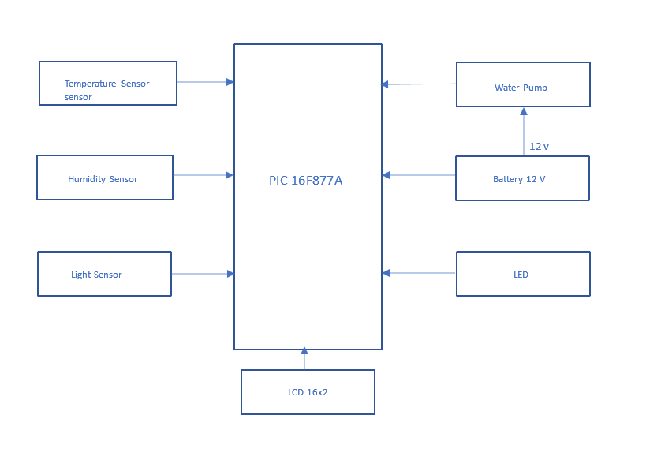

Figure 1 System Block Diagram

## d) Flow chart

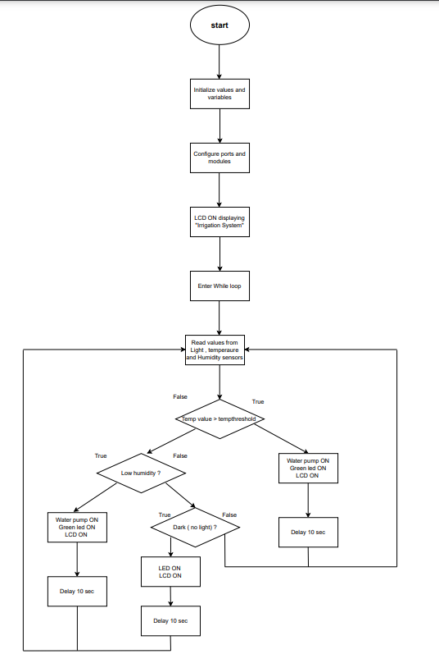

Figure 2 System Flow chart

# **Problems and recommendations**

During the development of the smart irrigation system, several challenges were faced:

1. **Sensor Accuracy and Calibration:**
   * Problem: Sensors may exhibit inaccuracies or require periodic calibration, affecting the reliability of soil moisture, light, and temperature readings.
   * Recommendation: Implement a regular calibration routine and consider sensor quality during component selection. Provide an option for manual calibration if needed.
2. **Environmental Durability:**
   * Problem: Exposure to harsh weather conditions can impact the durability and lifespan of system components.
   * Recommendation: Enhance the enclosure design to improve weather resistance. Use materials that withstand environmental challenges, such as waterproofing for electronic components.
3. **Cost Constraints:**
   * Problem: Budget limitations may restrict the use of high-quality sensors and components, potentially affecting system performance.
   * Recommendation: Explore cost-effective alternatives without compromising essential functionalities. Seek partnerships or sponsorships to alleviate financial constraints.
4. **Water Pump Efficiency:**
   * Problem: Inefficient water pump operation may affect water delivery precision and increase energy consumption.
   * Recommendation: Optimize pump efficiency through proper sizing, periodic maintenance, and monitoring. Consider variable-speed pumps for improved control.

Addressing these problems through the recommended solutions will contribute to the overall success, reliability, and user satisfaction of the smart irrigation system. Regular updates and improvements based on user feedback and evolving technologies should also be considered.

# **4. Conclusion**

In conclusion, our Smart Irrigation System with the PIC16F877A microcontroller is a positive step toward making farming smarter and more efficient. By using sensors to understand when plants need water, light, and optimal temperatures, we can conserve water and promote better plant growth.

The project emphasizes not only technological innovation but also the importance of user education. Clear guides and easy interfaces make the system accessible to everyone.

Looking ahead, the system is designed for future upgrades, allowing for additional features and improvements as agriculture technology advances.

In summary, our Smart Irrigation System is a user-friendly, sustainable solution that contributes to smarter and more effective farming practices, laying the groundwork for future innovations in agriculture.

# **5. References**

[Masters](https://www.wiley.com/en-us/search?pq=%7Crelevance%7Cauthor%3AGilbert+M.+Masters), [Gilbert](https://www.wiley.com/en-us/search?pq=%7Crelevance%7Cauthor%3AGilbert+M.+Masters) , Renewable and Efficient Electric Power Systems, 2013

Designing Embedded Systems with PIC Microcontrollers Principles and Applications, 2nd edition, 2009, Tim Wilmshurst, ISBN: 978-1-85617-750-4 2. Hardware: PIC16F877A